**Civil Engineering Research Project Guidebook –**

**Thesis Writing**

**2016**

**Engr. Reynaldo Perez-Ramos, PhD**

**College of Engineering and Technology**

**ROMBLON STATE UNIVERSITY**

**MIMAROPA Region**

**PHILIPPINES**

10/10/2016

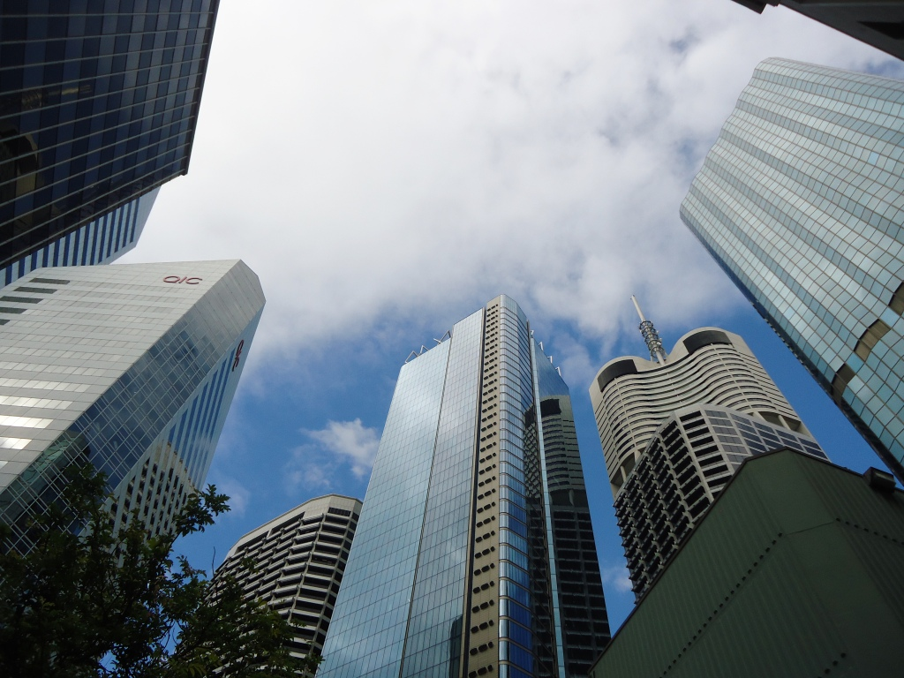

2 single spacing, 12 font size, center, bold letters

**Top Margin: 1.5”**

**UTILIZATION OF RICE HUSK ASH AS AN ADDITIVE IN BRICKS**

**Right Margin: 1”**

**Left Margin: 1.5”**

6 single spacing, 12 font size

**A Research Proposal Presented to the**

**Faculty of the College of Engineering and Technology**

**Romblon State University**

**Odiongan, Romblon**

6 single spacing, 12 font size

**In Partial Fulfilment of the Requirements for the Degree**

**Bachelor of Science in Civil Engineering**

4 single spacing, 12 font size

**By**

**Blasurca, Marco G.**

**Familara, Shiela Jane D.**

**Gregorio, Ma. Salve G.**

**Manalon, Jake Emelito G.**

**Rubion, Arvilyn S.**

**Rubion, Joven M.**

**Tadia, Jane Angelique F.**

**October 2016**

**Bottom Margin: 1”**



**ii**

**Top margin: 1”**

2 single spacing, 12 font size, center

**Left Margin: 1.5”**

**Justified, single spacing**

**APPROVAL SHEET**

2 single spacing, 12 font size, justified

The thesis entitled, “**TITLE OF THE STUDY IN BOLD CAPITAL LETTERS**”, prepared and submitted by **NAMES OF THE STUDENT RESEARCHERS (COMPLETE SURNAME, FIRST NAME INITIALS, MIDDLE INITIALS) IN BOLD CAPITAL LETTERS**, in partial fulfilment of the requirements for the degree of Bachelor of Science in Civil Engineering is hereby accepted for oral examination.

**Right Margin: 1”**

3 single spacing, 12 font size,center

**ENGR. REYNALDO P. RAMOS, PhD ENGR. ORLEY G. FADRIQUEL**

**Chairman, Panel of Examiners Member, Panel of Examiners**

3 single spacing, 12 font size

**ENGR. APRILLE ANN M. SIM ENGR. JASON F. RUFON**

**Member, Panel of Examiners Adviser**

3 single spacing, 12 font size

Approved and accepted as partial fulfilment of the requirements for the degree of **BACHELOR OF SCIENCE IN CIVIL ENGINEERING**.

3 single spacing, 12 font size, center

**ENGR. APRILLE ANN M. SIM**

**Chairman, Civil Engineering Department**

3 single spacing, 12 font size, center

**ENGR. ORLEY G. FADRIQUEL**

**Dean, College of Engineering and Technology**

Date: ______________

**Bottom margin: 1”**

**ACKNOWLEDGMENT**

Paging, bold

**iii**

**Top margin: 1”**

2 spacing, 12 font size, justified, double spacing

The students would like to express their gratitude and since thanks to the people who assisted and guided them in making this research proposal successful. (**LIMIT TO ONE PAGE ONLY).**

**Left Margin: 1.5”**

**Right Margin: 1”**

**Blasurca, M. G.**

**Familara, S. D.**

**Gregorio, Ma. S. G.**

**Manalon, J. E. G.**

**Rubion, A. S.**

**Rubion, J. M.**

**Tadia, J. A. F.**

**Bottom margin: 1”**

**TABLE OF CONTENTS**

**Top margin: 1”**

**iv**

2 single spacing, 12 font size, justified

**Left Margin: 1.5”**

**Contents Page**

**TITLE PAGE**  i

**Right Margin: 1”**

**APPROVAL SHEET** ii

**ACKNOWLEDGMENT**  iii

**TABLE OF CONTENTS** iv

Use Tab for alignment, single spacing

**LIST OF TABLES** v

**LIST OF FIGURES** v vi

**LIST OF APPENDICES** vii

**ABSTRACT** viii

**CHAPTERS**

**I INTRODUCTION** 1 – 6

Background of the Study 1

Objective of the Study 3

Significance of the Study 4

Scope and Delimitation of the Study 6

**2 REVIEW OF RELATED LITERATURE** 7 – 15

Related Literature 7

Related Studies 10

Conceptual Framework 11

Definition of Terms 13

Hypothesis of the Study (if applicable) 14

**3 RESEARCH METHODOLOGY** 16 – 22

Research Materials 16

Research Equipment 17

Research Locale and Time of Study 18

Research Methods 20

**4 RESULT AND DISCUSSION** 22 – 30

Result of the Experiment 22

Statistical Data and Result 23

Testing Performance 26

Financial Analysis (if applicable) 30

**5 SUMMARY, CONCLUSION AND RECOMMENDATION** 31 – 36

Summary 31

Conclusion 32

Recommendation 35

**REFERENCES** 36

**APPENDICES**

**Bottom margin: 1”**

**Top margin: 1”**

**v**

**LIST OF TABLES**

**Left Margin: 1.5”**

2 spacing, 12 font size, center

**Title Page**

single spacing, 12 font size, justified

1 List of Materials 16

2 List of Equipment 17

**Right Margin: 1”**

3 Mixture of the Samples 22

4 Test Results of Compressive Strength 23

5 Test Results of Water Absorption 24

6 Mean Values of Test Results 25

Use Tab for alignment

Indent, 1 Tab

**Bottom margin: 1”**

**vi**

**Top margin: 1”**

**Left Margin: 1.5”**

**LIST OF FIGURES**

2 spacing, 12 font size, justified

**Title Page**

1 Input-Output-Process 11

2 Materials Used 16

**Right Margin: 1”**

3 Grinding of Rice Husk Ash 17

4 Mixing of Materials 20

5 Comparison of the Performance 26

Use Tab for alignment

Indent, 1 Tab

**Bottom margin: 1”**

**LIST OF APPENDICES**

**vii**

**Top margin: 1”**

**Left Margin: 1.5”**

2 spacing, 12 font size, justified

**Title Page**

1 Input-Output-Process 11

2 Materials Used 16

3 Grinding of Rice Husk Ash 17

4 Mixing of Materials 20

5 Comparison of the Mixtures and Performance 26

**Right Margin: 1”**

Use Tab for alignment, single space

Indent, 1 Tab

**Bottom margin: 1”**

**Top margin: 1”**

**ABSTRACT**

viii

2 spacing, 12 font size

**BLASURCA, MARCO G.; FAMILARA, SHIELA JANE D.; GREGORIO, MA. SALVE G.; MANALON, JAKE EMELITO G.; RUBION, ARVILYN S.; RUBION, JOVEN M.; TADIA, JANE ANGELIQUE F.,** College of Engineering and Technology, Romblon State University, (*date of submission*). (**TITLE OF THE THESIS**).

2 spacing, 12 font size

**Adviser: (Name of the Faculty)**

Indent, 1 Tab, double spacing, justified

2 spacing, 12 font size

The abstract is a brief and concise descriptive summary of the study which contains the statement of the problem or the main objective of the study, research design, significance of the study, research instruments, techniques, data gathering procedure, data processing method, findings, conclusions, and recommendations.

**Right Margin: 1”**

**LIMIT TO 1-2 PAGES FOR THE ABSTRACT.**

**Bottom margin: 1”**

**CHAPTER I**

2 Double spacing, 12 font size

**Top margin: 1”**

*No page #*

Indent, 1 Tab, justified

**INTRODUCTION**

This chapter presents the background of the study, objectives of the problem, significance of the study, scope, and delimitation of the research study.

2 double spacing, 12 font size

**BACKGROUND OF THE STUDY**

This section of the report provides the overview discussion of the study, particularly the research problem – the “rationale” (basis, motivation, justification) of doing the research. Highlights of the related literature review are included in this section by citing important phrases and sentences from relevant secondary sources of information. This will also provide the reader general idea and impression about the topic under study.

2 double spacing, 12 font size, justify

**STATEMENT OF THE PROBLEM/OBJECTIVES OF THE STUDY**

The statement of the research problem must be brief but comprehensive and should have practical importance. A good problem statement is concerned with relation between two or more variables. It is stated clearly without ambiguity and is capable of empirical testing. Thus, the statement of the problem is in a simple language. It is specific, clear and limited. It directs the researcher and the research process, and suggests a specific answer or conclusion. It is the “verbalization of the “questions” which the study proposes to answer.

**Bottom margin: 1”**

**Paging, bold**

**2**

**Top margin: 1”**

On the other hand, the main objective of the research study is a statement of purpose because this is the guide to be accomplished by the researcher in conducting the research.

***Example A****: The main objective is to analyze and evaluate the electrical system of the main campus of Romblon State University (RSU). Specifically, it attempts to answer the following research questions:*

1. *What is the total load capacity of the transformers that can hold the power requirements of the RSU-main campus?*
2. *What is the total power rating used in the university?*

**Left Margin: 1.5”**

1. *How to maximize and minimize the loading capacity used in the university?*

***Example B:*** *This study aims to design and develop an inlet valve using Bluetooth technology. In particular, the study attempts to answer the following research questions:*

1. *What is the distance of the blue-valve from the Bluetooth technology for water supply control system application in both residential and commercial buildings?*
2. *What is the cost in the application of Bluetooth technology for water supply control system?*
3. *What the level of performance of the developed water supply control system?*

**Right Margin: 1”**

**Bottom margin: 1”**

**Left Margin: 1.5”**

**Top margin: 1”**

**SIGNIFICANCE OF THE STUDY**

**3**

This section of the report explains the contributions of the study either to a body of scientific knowledge, to practitioners/researchers in the same area of the research, or to any other group (students, local community, etc.) which benefit from the outcomes or results of the study. In other words, this answers the following questions: Why is it important for the research study to be conducted? Who will benefit from it, and what benefits could be derived from the results of the study? The research should clearly explain the intention of the researcher, the relevance, and the important implications of the study in solving a problem or a need of the society or community, knowledge gaps, or enriching existing research instruments and methods.

2 double spacing, 12 font size, justify

**SCOPE AND DELIMITATION OF THE STUDY**

This section explains the coverage of the study area, the subject being focused by the study, the research instruments or methods, duration of the study, and the constraints or limitations that have direct implication on the result of the study.

**Bottom margin: 1”**

**CHAPTER II**

2 double spacing, 12 font size, center

**Top margin: 1”**

*No page #*

Indent, 1 Tab, justified

**LITERATURE REVIEW**

This chapter presents the legal bases, literature, and studies which are relevant to the research study. The main purposes of the literature review are (a) to determine the similarities and differences of the on-going study and past studies; (b) to acquire additional insights and ideas related to the problem being addressed in the study. Observe proper referencing or citation of the sources of information, using the American Psychological Association (APA) styles to avoid copying or “plagiarism” or infringement. Plagiarism is a violation of Republic Act 8293 known as the Intellectual Property Code of the Philippines. This act provides legal basis in proper use of passages, writings, ideas and statements of other authors/writers by giving due credit of their work.

2 double spacing, 12 font size, center

**RELATED LITERATURE**

This sub-section of the literature review covers those related literature from published articles, books, journals that have connection or linkages to the study conducted (Ramos, 2015; Ramos et al., 2011)

2 double spacing, 12 font size, justified

**RELATED STUDIES**

The sub-section covers published and unpublished research works which are related to the study. According to Ramos (2011), it is necessary to highlight the significant findings from these researches that have similarities and differences to the on-going study. The present or current and latest related studies are presented first, then following by those past ones. Please note that **Wikipedia sources is not allowed**.

**Bottom margin: 1”**

**4**

**Top margin: 1”**

2 double spacing, 12 font size, justified

**CONCEPTUAL FRAMEWORK**

This section explains both the theoretical and conceptual framework of the study. It gives a clear discussion regarding the research paradigm used in the conduct of the study. A typical model is the **INPUT-PROCESS-OUTPUT** which constitutes the flow of the activities, including the relationship of selected variables.

2 double spacing, 12 font size, justified

**SYNTHESIS**

This contains summary of the review of past studies that are relevant to the present conduct of the study. It is worth mentioning the methods, procedures, and framework adopted from the literature.

2 double spacing, 12 font size, justified

**DEFINITION OF TERMS**

This is to enumerate the key terms used in the study and it is recommended to use the “operational term” in defining these key terms. It is operational term when it is based on an observed characteristic and how this term is used in the study.

2 double spacing, 12 font size, justified

**Inlet** – it is a tube or hollow cylinder used to convey materials or as a structural component.

**Pressure** – it is the energy that the system needs to deliver the water.

2 double spacing, 12 font size, justified

**HYPOTHESIS OF THE STUDY (IF APPLICABLE)**

**Right Margin: 1”**

**Bottom margin: 1”**

**CHAPTER III**

2 double spacing, 12 font size, center

**Top margin: 1”**

*No page #*

Indent, 1 Tab, justified

**RESEARCH METHODOLOGY**

This chapter presents the methodology used in the study, including the materials and equipment or instruments used, selection of respondents (if applicable, and instruments (questionnaire, case study), and the overall procedures in the data collection and the statistical treatment of the data collected.

2 double spacing, 12 font size, center

**Left Margin: 1.5”**

**RESEARCH MATERIALS**

2 double spacing, 12 font size, center

**RESEARCH EQUIPMENT**

2 double spacing, 12 font size, center

**RESEARCH LOCALE AND TIME OF STUDY**

2 double spacing, 12 font size, center

**RESEARCH METHODS**

**Right Margin: 1”**

**Bottom margin: 1”**

**CHAPTER IV**

2 double spacing, 12 font size, center

**Top margin: 1”**

*No page #*

Indent, 1 Tab, justified

**RESULT AND DISCUSSION**

This chapter presents the important findings of the study. Findings should answer the research questions as stated in **Chapter 1** or answering the research objectives.

2 double spacing, 12 font size, center

**RESULT OF THE EXPERIMENT**

**Left Margin: 1.5”**

2 double spacing, 12 font size, center

**Right Margin: 1”**

**STATISTICAL DATA AND RESULT**

2 double spacing, 12 font size, center

**TESTING OF PERFORMANCE**

2 double spacing, 12 font size, center

**FINANCIAL ANALYSIS (IF APPLICABLE)**

Double spacing, 12 font size, center

**Table 1. Tables and figures should be valuable, relevant, and visually attractive.**

|  |  |  |  |
| --- | --- | --- | --- |
| Heading | Heading | Heading | Heading |
| Component |  |  |  |
| Component |  |  |  |
| Total |  |  |  |

Tables (title is placed on top) and figures (title is placed at the bottom) should be carefully explained in the text and cited in numerical order. Use basic colors in the figures, charts, and diagrams (**Table 1**)

**Bottom margin: 1”**

**6**

**Top margin: 1”**

**Figure 1: Comparison of success rate of items in the experimental and control class.**



**Figure 2: Clear line drawings are essential.**

**Bottom margin: 1”**

**CHAPTER V**

2 double spacing, 12 font size, center

**Top margin: 1”**

*No page #*

Indent, 1 Tab, justified

**SUMMARY, CONCLUSION AND RECOMMENDATION**

This chapter presents the highlights of the key results of the study, including the recommended future researches towards for further investigations.

2 double spacing, 12 font size, center

**SUMMARY**

Summary should be based on the major findings or results of the study which answer the research questions as stated in Chapter 1 or answering the research objectives.

2 double spacing, 12 font size, center

**CONCLUSION**

Conclusions should be based on the major results that have contributions to the body of knowledge

2 double spacing, 12 font size, center

**RECOMMENDATION**

**Right Margin: 1”**

**Left Margin: 1.5”**

**Bottom margin: 1”**

**REFERENCES**

**Right Margin: 1”**

**Left Margin: 1.5”**

**Top margin: 1”**

Ramos, R. P. (2015). *Title of the Book.* City, Country: Publisher. (example citation from a book)

Ramos, R. P. (2014). Title of the Article. *Name of the Journal, Volume* (Nos.), pages. (example citation of a journal)

Ramos, R. P. (2016). Research Methodology. Retrieved from <http://www.bolender.com/action.htm> (example of citation from an online source)

Castillo, F.S. (2007). *Research Education and Scientific Writing* (Latest Ed.). Manila, Philippines: Booklore Publishing Corporation (from a book with one author)

Sha, A. S. (2011). *Research Methodology*. New Delhi, India: A P H Publishing Corporation (from a book with one author)

Paler-Calmorin, L. & Calmorin M. A. (2007). *Research Methods and Thesis Writing,* (Second ed.). Manila, Philippines: Rex Printing Company, Inc. (from a book with two authors)

Ramos, R. P. (2011). *Analysis of Mixed-use Schemes in Regeneration Areas*. Ph.D dissertation, Faculty of Art, Design and the Built Environment, University of Ulster (example of citation from PhD dissertation)

Dela Vega, M., Gado, J. R., Galanga, C. M., Gaytano, G. F., Marcelo, E. S., Mayor, K. F., Mindoro, A. M., Morines, C. B., Motin, M. E., Overio, C S., & Teologo, R. G. (2016). *Bluetooth Application for Water Supply Control System*. Master thesis, College of Engineering and Technology, Romblon State University (example of citation from a Master’s thesis)

**Bottom margin: 1”**

**APPENDICES**

**Top margin: 1”**

**Right Margin: 1”**

**Left Margin: 1.5”**

**DOCUMENTATION**

Include photographs, figures, tables, diagrams, charts, test results, standard procedures, programming, plans and drawings, with proper captions or titles.

Double spacing, 12 font size, center

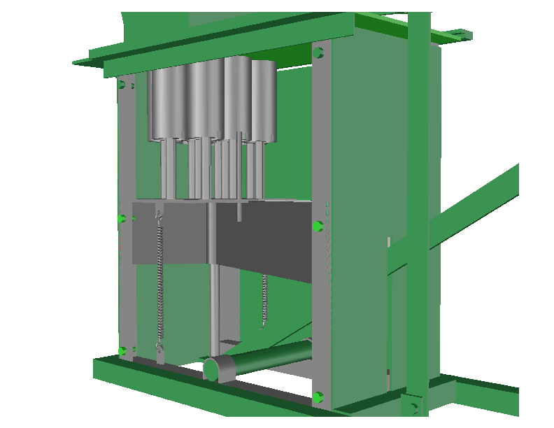

Cylindrical molds

Spring

**The Briquetting chamber**

**BIOGRAPHICAL SKETCH**

This includes a brief profile of the student researchers with clear 2x2 photo size, with signature specimen of the student.

**Bottom margin: 1”**

**CERTIFICATE OF ENGLISH CRITIC**

A certification from an English teacher that the report is properly checked to meet University’s technical writing standards.

**SIDE OF THE BINDED THESIS (RED COLOR)**

**THESIS BACHELOR OF SCIENCE IN CIVIL ENGINEERING BLASURCA, M. ET AL. OCT 2016**

**FRONT COVER OF THE BINDED THESIS (RED COLOR)**

**Top margin: 2”**

**UTILIZATION OF RICE HUSK ASH AS AN ADDITIVE IN BRICKS**

**Blasurca, Marco G.**

**Familara, Shiela Jane D.**

**Gregorio, Ma. Salve G.**

**Centered, middle of the page**

**Manalon, Jake Emelito G.**

**Rubion, Arvilyn S.**

**Rubion, Joven M.**

**Tadia, Jane Angelique F.**

**OCTOBER 2016**

**2” margin**

***DISCLAIMER FOR USE***

***This document is a draft copy of the Research Project (Thesis Writing) guidelines that serves as a reference in the final preparation of the proposal and submission of the thesis. This is only intended for the 4th/5th year students of the College of Engineering and Technology of the Romblon State University who are taking-up the subject, Research Projects 1 and 2.***

***This document as a reference material is allowed for academic purposes only. However, commercial reproduction in any form (printing and digital formats) requires prior approval of the author.***

***Write your comments to:***

***ENGR. REYNALDO PEREZ-RAMOS***

***Associate Professor***

***College of Engineering and Technology***

***Romblon State University***

***Odiongan, Romblon***

***Philippines***

***Email:*** [***rsu.rpramos@gmail.com***](mailto:rsu.rpramos@gmail.com)

***Website:*** [***www.rsucivilengineering.weebly.com***](http://www.rsucivilengineering.weebly.com)

***Copyright October 2016***