FINAL GROUP WORK REPORT PREPARATION
Additional Reference Materials in the Preparation of a River System Assessment Map
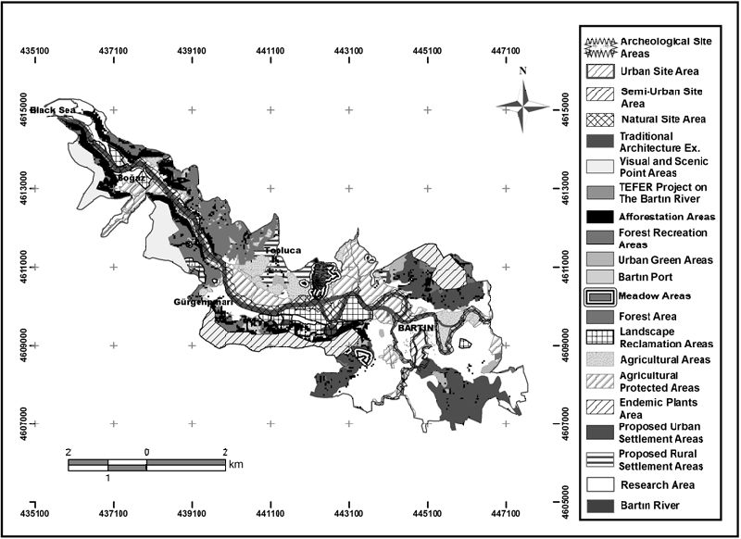
Figure 1. Indicate the major existing land uses or major activities along the river. Major structures and facilities, built-up areas, vegetations, forest, mangroves, and environmental problems/issues present in the area should be indicated in the map.

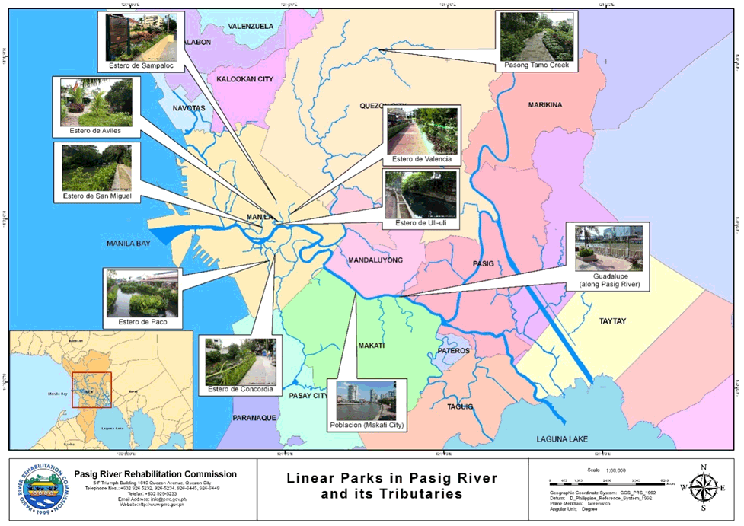
Figure 2: The maps major parks and tributaries (esteros), with photos and captions to highlight the strengths – current improvement in the area. You can prepare the map using the SWOT Analysis – Strengths-Weaknesses-Opportunities and Threats.

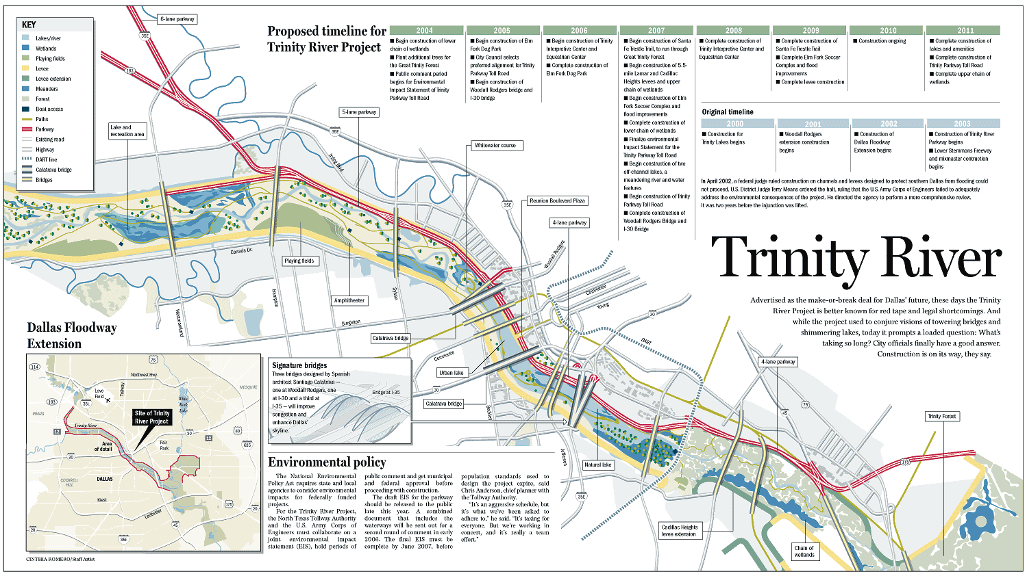

Figure 3 : This map shows the projects, plans, and programs, including strategies to improve the river system. This map shows the major proposals to address the current problems or threats along the river towards the improvement of the water quality and its total environ.

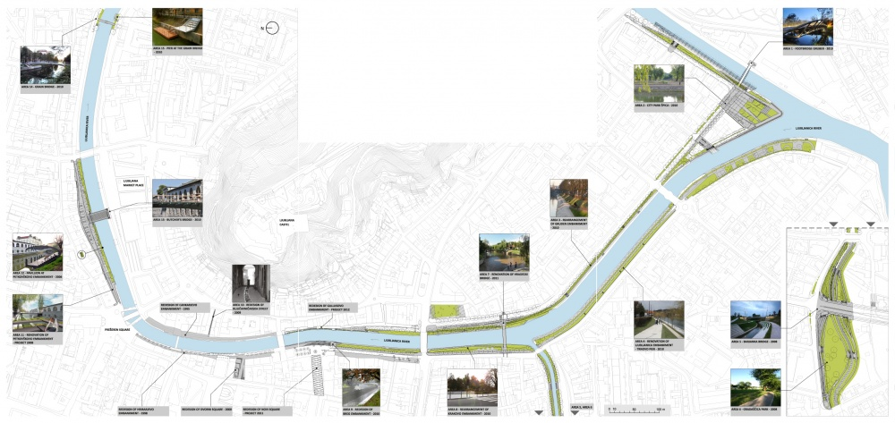
Figure 4: This map show the significant structures and land uses along the river. You can include images/photos to improve the presentation on the map. Include the description of the photos/images as well.

