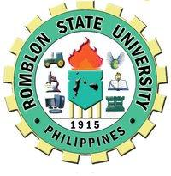
ROMBLON STATE UNIVERSITY
College of Engineering and Technology
Main Campus, Odiongan, Province of Romblon

INDIVIDUAL ASSIGNMENT #3
REACTION PAPER

ME326 ENVIRONMENTAL ENGINEERING Due Date: 17 January 2018
Engr. Reynaldo P Ramos, PhD

TOPIC: RA9003 and Solid Waste Management

INSTRUCTION:
This is a writing of a 150-word Reaction Paper. The 150 words - the minimum requirement word count to write a review of a video clip entitled HIWALAYAN: A Solid Waste Management Campaign in the Philippines starring Vilma, Nora and P-noy.
The following questions will be answered:

- What is the central theme of the video?
- Who are the main characters of the story? Briefly describe them.
- What is the moral lesson of the story?
- The reaction paper will be handwritten in your notebook.

