Romblon State University
INSTITUTE OF GRADUATE STUDIES
Odiongan, Romblon
Tel. no. (042) 567-5952
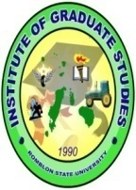
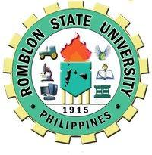
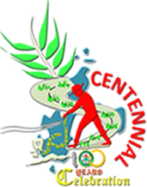

FINAL PROJECT GUIDELINES
GRAD EARTH SCIENCE/ENVIRONMENTAL SCIENCE TTH 1:00-5:00PM
Engr. Reynaldo P Ramos, PhD TTH 5:00-9:00PM

DEVELOPMENT OF AN EDUCATIONAL VISUAL AID MATERIAL
The final project aims to provide a simple way on how the students will be able to illustrate the ideas/concepts/application learned from the class. Ultimately, the final output will be used as an educational visual aid for class discussion or for information and educational campaign to increase the level of awareness among students and employees of your organization.

General Mechanics

- This will be undertaken by an individual or group of 2 students. Make sure that this is AN ORIGINAL output.
- Choose a particular topic related to Environmental Science or Earth Science (whichever applies to you) that will presented in ONE WHOLE SIZE OF ILLUSTRATION BOARD, or create a DIGITAL or other form of media materials.
- The final output in the illustration board should be plastic covered, while the digital or media materials should be stored in a CD.
- Clearly indicate the names of the students who prepared the materials.
- BE INNOVATIVE+ CREATIVE!

Theme Coverage
- The topic to be illustrated or digitized includes: environmental pollution or environmental issues related to air, water, people and land; and other concerns addressed in the 17 development goals promoted by UN.
- Be specific with the topic to be covered in the visual aid material.
- All information to be incorporated in the final output should be properly acknowledged to avoid “plagiarism”.
- Using collage of photos/pictures and other graphics should be morally acceptable and in public domain.

DATE OF SUBMISSION: 31 May 2017, 5PM OR EARLIER DATES
NON-SUBMISSION MEANS INCOMPLETE AND A GRADE OF 2 UPON COMPLIANCE

