Romblon State University
INSTITUTE OF GRADUATE STUDIES
Odiongan, Romblon
Tel. no. (042) 567-5952

HANDOUT #1
GRAD/SCI221 ENVIRONMENTAL SCIENCE SATURDAY 10:00AM-1:00PM
Engr. Reynaldo P Ramos, PhD

INTRODUCTION
Environment: In operational term, it refers to the surroundings which relate to day-to-day activities associated with the following aspects: water quality, air quality, waste management, urban development and other issues with global and local impacts. It encapsulates all the 4 dimensions: biophysical, social, economic and political) which define our surroundings. It also refers to our natural surroundings which have traditionally being described in bio-physical terms. In broader definition, it encompasses the following:
- Ecosystems and their interactive parts
- Natural and physical resources
- Characteristics and qualities of communities, areas and locations which influence the balance, well-being and amenity of society
- The social, economic and cultural dimensions which define and influence the health of all communities, including human settlement.
Science: It is an approach to studying the natural world that involves formulating hypotheses and then testing them to see if the hypotheses are supported or refuted.
Engineering: Application of science Examples: civil engineering – design of buildings and use machines).
Difference between science and engineering: Traditionally, science and engineering have been seen as resting on fundamentally different philosophies and goals with science underpinning (foundation, support) engineering and providing the basic knowledge and understanding for engineering decisions. The focus of science is on understanding the nature of things and the causes of their behavior – its basic question is “Why”. The basic question for engineering is “How”, thus the profession (civil engineers) focuses on providing practical solutions to serve human needs. Science: discovery (mainly by controlled experimentation); drawing correct conclusion based on good theories and accurate data. Engineering: Invention, design and production; reaching good decision based on incomplete data and approximate models.
Ecology: The study of the relationships between living organisms (biota) and their physical environment (abiota). In its broadest sense, it is the study of organisms as they exist in their natural environment.
Ecosystem: It is a region in which the organisms and the physical environment form interacting unit. Within an ecosystem, there is a complex network of interrelationships. For example, weather affects plants; and plants evaporate water which also affects weather.
Environmental Science: It is a branch of science that deals with the environment (ecological system/ecosystem). It involves an understanding of scientific principles, economic influences, and political action. It is a mixture of the traditional science, individual and social values, economic factors, and political awareness that are important to solving environmental problems.
Environmental Engineering: It deals on the environmental problems, together with its solutions, including effect of technological advances on the environment. This is derived from civil engineering.
Environmental Management: It is the management of activities within tolerable constraints imposed by the environment itself, and full consideration of ecological factors. It covers issues on environmental impact, sustainability, resource and waste management, and control of emissions and pollution.

SUSTAINABILITY and SUSTAINABLE DEVELOPMENT
Engineers and scientists play crucial roles in improving living standards throughout the world. As a result, engineers and scientists can have a significant impact on progress towards sustainable development.
Sustainability: It refers to the state at which something (ie economy or human way of life) is able to continue and be sustained undiminished over time (environmentally, socially, etc). It is the ultimate goal or destination. The domain of sustainability – is the key aspect of the concept is the integration of economic, environmental and social factors.
Social
Economic

^{Ecological}
Social
Economic

Ecological

Social
Economic

Ecological

- (b)

(c)

Sustainable development: It is the path or framework to achieve sustainability.
(From Brundtland Commission Report, 1987 UN World Commission on Environment and Development, Our Common Future, 1987; 1992 UN Conference on Environment and Development Earth Summit) defined as: “development that meets the needs of the present without compromising the ability of future generations to meet their own needs.”
The concept of sustainable development has been expanded to cover seven key aspects:
- Futurity
- Inter-generation equality
- Participation
- The balancing of economic and environmental factors
- Environmental capacities
- Emphasis on quality as well as quantity
- Compatibility with local ecosystems

Existing and Emerging Environmental Issues (UN Environment Programme, 2002)
- Globalisation, trade and development
- Coping with climate change and variability
- Growth of megacities
- Human vulnerability to climate change
- Freshwater depletion and degradation
- Marine and coastal degradation
- Population growth
- Rising consumption in developing countries
- Biodiversity depletion
- Biosecurity

MILLENIUM DEVELOPMENT GOALS (MDGs): http://www.undp.org/content/undp/en/home/sdgoverview/mdg_goals.html
- To eradicate extreme poverty and hunger
- To achieve universal primary education
- To promote gender equality and empower women
- To reduce child mortality
- To improve maternal health
- To combat HIV/AIDS, malaria, and other diseases
- To ensure environmental sustainability
- To develop a global partnership for development

2030 Sustainable Development Goals (SDGs)
http://www.undp.org/content/undp/en/home/sdgoverview/post-2015-development-agenda.html
https://sustainabledevelopment.un.org/sdgs
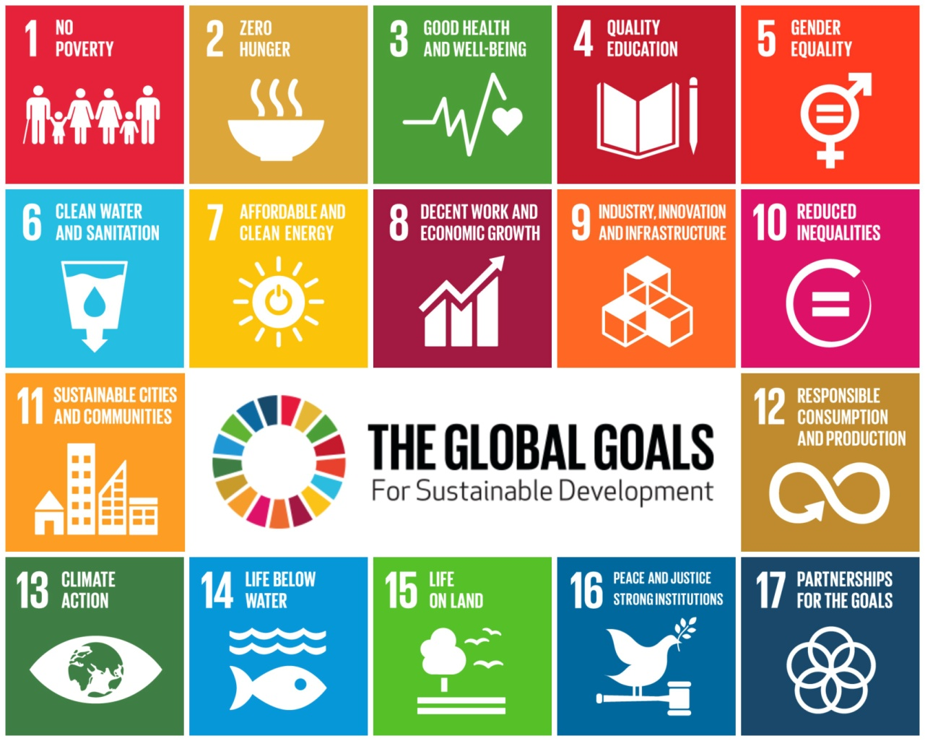

The SAN DESTIN DECLARATION: 9 Principles of SUSTAINABLE Green Engineering
- Engineer processes and products holistically, use systems analysis, and integrate environmental impact assessment tools.
- Conserve and improve natural ecosystems while protecting human health and well-being.
- Use life-cycle thinking in all engineering activities.
- Ensure that all material and energy inputs and outputs are as inherently safe and benign as possible.
- Minimize depletion of natural resources.
- Strive to prevent waste.
- Develop and apply engineering solutions, while being cognizant of local geography, aspirations, and cultures.
- Create engineering solutions beyond current or dominant technologies; improve, innovate, and invent (technologies) to achieve sustainability.
- Actively engage communities and stakeholders in development of engineering solutions

PHILIPPINE AGENDA 21/National Education Action Plan (NEAAP – 2005-2014) Key elements of sustainable development for 2005-2014 must support: poverty reduction, social equity, empowerment and good governance, peace and solidarity, and ecological integrity. In terms of Education for Sustainability aims to pursue education to foster the transition to a sustainable society. As a process, education for sustainable development is used to: create awareness of sustainable development issues, enhance knowledge and understanding skills, influence values and attitudes, encourage more responsible behaviour, and promote learning that leads to action.

EPA 21: Sustainable Development in the Philippine Context
http://pcsd.neda.gov.ph/publications/epa-21/#
The Philippines was one of the first countries that swiftly responded to the calls made at the Earth Summit. Three months after the Summit, the government established the Philippine Council for Sustainable Development (PCSD) to oversee the implementation of the country’s Agenda 21 commitments and formulate policies and programs that are supportive of sustainable development. In fulfilment of its mandate, the PCSD coordinated the formulation, through a consensus building process, of a national agenda and blueprint for sustainable development now known as Philippine Agenda 21 (PA 21).
http://www.neda.gov.ph/2013/10/21/philippine-development-plan-2011-2016/

http://www.neda.gov.ph/wp-content/uploads/2013/09/CHAPTER-10.pdf
The Philippine Development Plan 2011-2016 adopts a framework of inclusive growth, which is high growth that is sustained, generates mass employment, and reduces poverty. With good governance and anticorruption as the overarching theme of each and every intervention, the Plan translates into specific goals, objectives, strategies, programs and projects all the things that we want to accomplish in the medium term.
Through this Plan, we intend to pursue rapid and sustainable economic growth and development, improve the quality of life of the Filipino, empower the poor and marginalized and enhance our social cohesion as a nation. Our strategic development policy framework thus focuses on improving transparency and accountability in governance, strengthening the macroeconomy, boosting the competitiveness of our industries, facilitating infrastructure development, strengthening the financial sector and capital mobilization, improving access to quality social services, enhancing peace and security for development, and ensuring ecological integrity.
The Philippine Development Plan will serve as our guide in formulating policies and implementing development programs for the next six years. It enables us to work systematically to give the Filipino people a better chance of finally finding their way out of poverty, inequality, and the poor state of human development.

SUGGESTED READING MATERIALS
- Davis, M. L. And Masten, S.J. (2004). Principles of Environmental Engineering and Science, International Edition, McGraw-Hill Education (Asia), New York, ISBN 007-123728-3
- Enger, E D., and Smith, B F. (2009). Environmental Science, A Study of Interrelationships, 11th Edition, McGraw Hill International Edition (Asia)
- Gagalac-Regis, Emelina, Labra-Espina, and Yacat, Ma Yvaine (2001). The Pasig River: Caring for a Dying Ecosystem, Pasig River Rehabilitation Commission, Manila
- Harding, R (1998). Environmental Decision-Making, The Federation Press, NSW, Australia
- Henry, J.G. and Heinke, G.W. (2000). Environmental Science and Engineering, Pearson Education Asia Pte., Ltd.,Singapore, ISBN: 981-4058-48-3
- Lee, S J, and Anes, M L. (2010). Environmental Science – The Economy of Nature and Ecology of Man, 2nd Edition, C & E Publishing, Inc., Quezon City, Philippines
- Mihelcic, J.R. and Zimmerman, J.B. (2010). Environmental Engineering Fundamentals, Sustainability, Design, John Wiley & Sons Singapore Pte, Ltd., Singapore, ISBN-13:978-981-253-340-1
- Miller, G., Jr. & Spoolman, S. (2013). Principles of Environmental Science, Cengage Learning Asia Pte, Ltd., Singapore
- Tayo, G. , Gascon, C., Maglambayan, V., Novicio, L., and Viril, V. (2004). Fundamentals of Environmental Science, Trinitas Publishing, Inc., Philippines
- Montgomery, Carla (2000). Environmental Geology, 5th Edition Update, McGraw-Hill Higher Education, USA
- Speight, J.G. and Lee S. (2000). Environmental Technology Handbook, 2nd Edition, Taylor & Francis, USA, ISBN: 1-56032-892-4
- Vesilind P.A, Morgan, S.M., and Heine, L.G. (2013). Introduction to Environmental Engineering, 1st Philippine reprint, Cengage Learning Asia Pte Ltd., Singapore, ISBN 13:978-981-4524-13-1

INDIVIDUAL ASSIGNMENT #1: Identify major environmental concerns or pressing issues/problems that
your organization is facing right now.
- Identify at least three (3) environmental problems or issues at the workplace.
- Explain the major causes/sources and its effects/consequences of each problem/issue.
- Identify the solutions or remedies and strategies to solve for each problem.
- Write your answers in one Letter size bond paper, 1.5 spacing, 11/12 font maximum of 5 pages.

