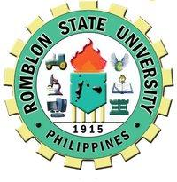
ROMBLON STATE UNIVERSITY
College of Engineering and Technology
Main Campus, Odiongan, Province of Romblon

HANDOUT #2

CE4113 ENVIRONMENTAL ENGINEERING MW: 10-11:30; TTH: 10-11:30AM
Engr. Reynaldo P Ramos, PhD MF: 4-5:30; TTH: 4-5:30PM

SUSTAINABLE ENGINEERING
It is defined as the design of human and industrial systems to ensure that humankind’s use of natural resources and cycles do not lead to diminished quality of life due either to losses in future economic opportunities or adverse impacts on social conditions, human health, and the environment (Mihelcic et al., 2003; As cited by Mihelcic & Zimmerman, 2010).

UNITED NATIONS (UN) CONFERENCE ON THE HUMAN ENVIRONMENT (Stockholm, 1972)
Principle 1: Man has the fundamental right to freedom, equality, and adequate conditions of life, environment of quality that permits a life of dignity and well-being, and he bears a solemn responsibility to protect and improve the environment for present and future generations.

Principle 2: The natural resources of the earth including air, water, land, flora, and fauna and especially representative samples of natural ecosystems must be safeguarded for the benefit of present and future generations through careful planning and management, as appropriate.

MILLENIUM DEVELOPMENT GOALS (MDGs)
World Summit on Sustainable Development in Johannesburg, South Africa in 2002. For each goal, one or more targets have been set, most of achievement by 2015, using 1990 as a benchmark. (www.un.org/milleniumgoals/)
http://www.undp.org/content/undp/en/home/sdgoverview/mdg_goals.html

- To eradicate extreme poverty and hunger - (More than a billion people still live on less than $1 a day. Target: Halve of the proportion of people living on less than $1 a day and those who suffer from hunger)
- To achieve universal primary education – (As many as 113 million children do not attend school. Target: Ensure that all boys and girls complete primary school)
- To promote gender equality and empower women – (Two-thirds of illiterates are women, and the rate of employment among women is two-thirds that of men. Target: Eliminate gender disparities in primary and secondary education preferably by 2005, and at all levels by 2015)
- To reduce child mortality – (Every year, nearly 11 million young children die before their 5th birthday, mainly from preventable illnesses. Target: Reduce by 2/3 the mortality rate among children under 5)
- To improve maternal health – (In the developing world the risk of dying in childbirth is one in 48. Target: Reduce by three-quarters the ratio of women dying in childbirth)
- To combat HIV/AIDS, malaria, and other diseases – (40 million people are living with HIV, including 5 million newly infected in 2001. Target: Halt and begin to reverse the spread of HIV/AIDS and the incidence of malaria and other major diseases)
- To ensure environmental sustainability – (More than 1 billion people lack access to safe drinking water and more than 2 million people lack sanitation. Target: Integrate the principles of sustainable development into country policies and programs and reverse the loss of environmental resource; Reduce by half the proportion of people without access to safe drinking water; Achieve significant improvement in the lives of at least 100 million slum dwellers)
- To develop a global partnership for development – (Target: Address the special needs of the least-developed countries; In cooperation with the private sector, make available the benefit of new technologies, especially information and communications)

2030 Sustainable Development Goals (SDGs)
https://sustainabledevelopment.un.org/sdgs
https://sustainabledevelopment.un.org/post2015/transformingourworld
http://www.undp.org/content/undp/en/home/sdgoverview/post-2015-development-agenda.html
This Agenda is a plan of action for people, planet and prosperity. It also seeks to strengthen universal peace in larger freedom. We recognise that eradicating poverty in all its forms and dimensions, including extreme poverty, is the greatest global challenge and an indispensable requirement for sustainable development. These 17 Sustainable Development Goals and 169 targets were based on the Millennium Development Goals and complete what these MDGs did not achieve such as achieve gender equality and the empowerment of all women and girls. These goals are integrated and indivisible and balance the three dimensions of sustainable development: the economic, social and environmental.
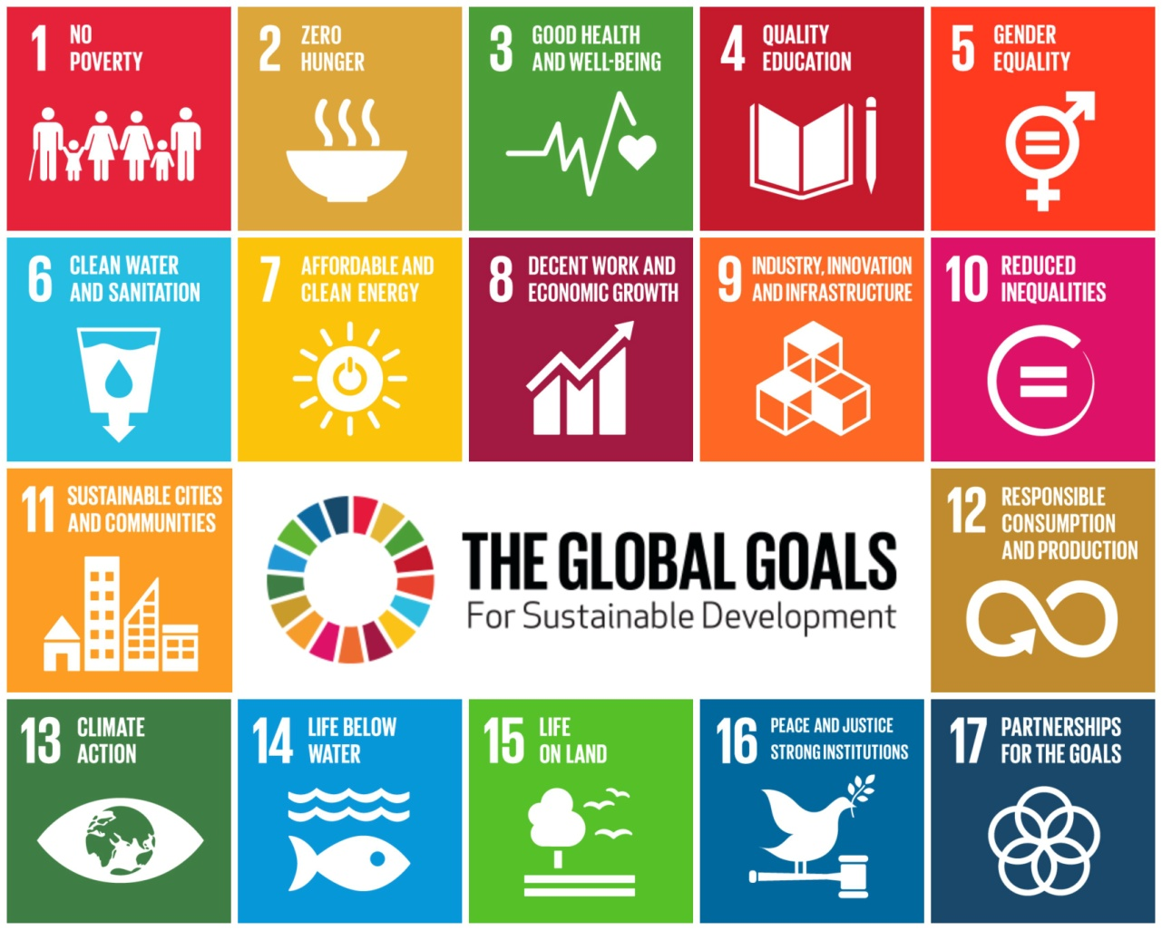

UNITED NATION’S AGENDA 21
https://sustainabledevelopment.un.org/outcomedocuments/agenda21
Agenda 21 is a comprehensive plan of action to be taken globally, nationally and locally by organizations of the United Nations System, governments, and major Groups in every area in which human impacts on the environment.
Agenda 21, the Rio Declaration on Environment and Development, and the Statement of principles for the Sustainable Management of Forests were adopted by more than 178 Governments at the United Nations Conference on Environment and Development (UNCED) held in Rio de Janerio, Brazil, 3 to 14 June 1992. The Commission on Sustainable Development (CSD) was created in December 1992 to ensure effective follow-up of UNCED, to monitor and report on implementation of the agreements at the local, national, regional and international levels. It was agreed that a five year review of Earth Summit progress would be made in 1997 by the United Nations General Assembly meeting in special session. The full implementation of Agenda 21, the Programme for Further Implementation of Agenda 21 and the Commitments to the Rio principles, were strongly reaffirmed at the World Summit on Sustainable Development (WSSD) held in Johannesburg, South Africa from 26 August to 4 September 2002 (source: UN)

PHILIPPINE AGENDA 21/National Education Action Plan (NEAAP – 2005-2014)
Key elements of sustainable development for 2005-2014 must support: poverty reduction, social equity, empowerment and good governance, peace and solidarity, and ecological integrity. In terms of Education for Sustainability aims to pursue education to foster the transition to a sustainable society. As a process, education for sustainable development is used to: create awareness of sustainable development issues, enhance knowledge and understanding skills, influence values and attitudes, encourage more responsible behaviour, and promote learning that leads to action.

EPA 21: Sustainable Development in the Philippine Context
http://pcsd.neda.gov.ph/publications/epa-21/#
The Philippines was one of the first countries that swiftly responded to the calls made at the Earth Summit. Three months after the Summit, the government established the Philippine Council for Sustainable Development (PCSD) to oversee the implementation of the country’s Agenda 21 commitments and formulate policies and programs that are supportive of sustainable development. In fulfilment of its mandate, the PCSD coordinated the formulation, through a consensus building process, of a national agenda and blueprint for sustainable development now known as Philippine Agenda 21 (PA 21).
http://www.neda.gov.ph/2013/10/21/philippine-development-plan-2011-2016/

http://www.neda.gov.ph/wp-content/uploads/2013/09/CHAPTER-10.pdf
The Philippine Development Plan 2011-2016 adopts a framework of inclusive growth, which is high growth that is sustained, generates mass employment, and reduces poverty. With good governance and anticorruption as the overarching theme of each and every intervention, the Plan translates into specific goals, objectives, strategies, programs and projects all the things that we want to accomplish in the medium term.
Through this Plan, we intend to pursue rapid and sustainable economic growth and development, improve the quality of life of the Filipino, empower the poor and marginalized and enhance our social cohesion as a nation. Our strategic development policy framework thus focuses on improving transparency and accountability in governance, strengthening the macroeconomy, boosting the competitiveness of our industries, facilitating infrastructure development, strengthening the financial sector and capital mobilization, improving access to quality social services, enhancing peace and security for development, and ensuring ecological integrity.
The Philippine Development Plan will serve as our guide in formulating policies and implementing development programs for the next six years. It enables us to work systematically to give the Filipino people a better chance of finally finding their way out of poverty, inequality, and the poor state of human development.

The SAN DESTIN DECLARATION: 9 Principles of SUSTAINABLE Green Engineering
- Engineer processes and products holistically, use systems analysis, and integrate environmental impact assessment tools.
- Conserve and improve natural ecosystems while protecting human health and well-being.
- Use life-cycle thinking in all engineering activities.
- Ensure that all material and energy inputs and outputs are as inherently safe and benign as possible.
- Minimize depletion of natural resources.
- Strive to prevent waste.
- Develop and apply engineering solutions, while being cognizant of local geography, aspirations, and cultures.
- Create engineering solutions beyond current or dominant technologies; improve, innovate, and invent (technologies) to achieve sustainability.
- Actively engage communities and stakeholders in development of engineering solutions.

GROUP WORK #1: PREPARE AND SUBMIT A COLLAGE PERTAINING TO 2030 SUSTAINABLE
DEVELOPMENT GOALS, DUE DATE: 17 July 2017
- Each group will be assigned to interpret two (2) SDGs.
Group 1: SDGs 1 and 2
Group 2: SDGs 3 and 4
Group 3: SDGs 5 and 6
Group 4: SDGs 7 and 8
Group 5: SDGs 9 and 10
Group 6: SDGs 11 and 12
Group 7: SDGs 13 and 14
Group 8: SDGs 15 and 16
Group 9: SDGs 11 and 17
- Using 1 whole illustration board, prepare/create a photo collage to illustrate the assigned SDGs.
- A photos collage is made of images or graphics using newspaper clippings, old magazines, and
other reading materials, including free graphics or images available online. Refrain from using copyrighted materials. Only decent images should be used.
- Additional points to the winning collage will be awarded to the group.
- BE CREATIVE AND INNOVATIVE!

